TOLGA BOROĞLU
Email: tolgaboroglu@gmail.com
Question 1:
https://github.com/tolgaboroglu/Datablast
Question 2:
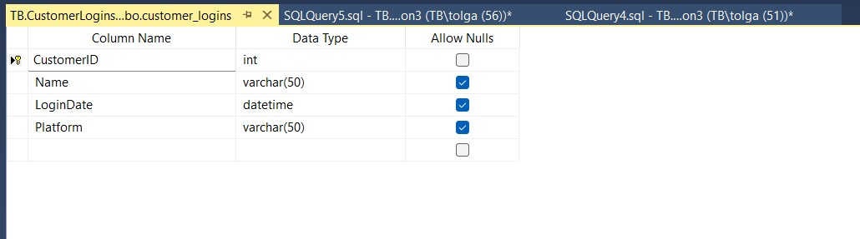
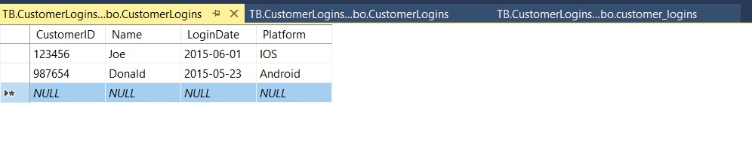
2.1
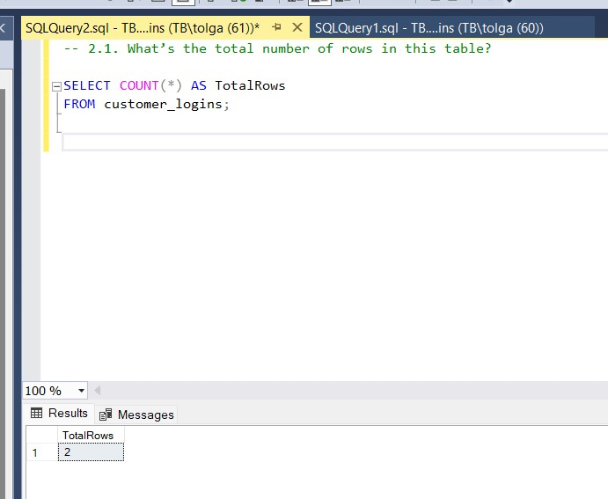

2.2
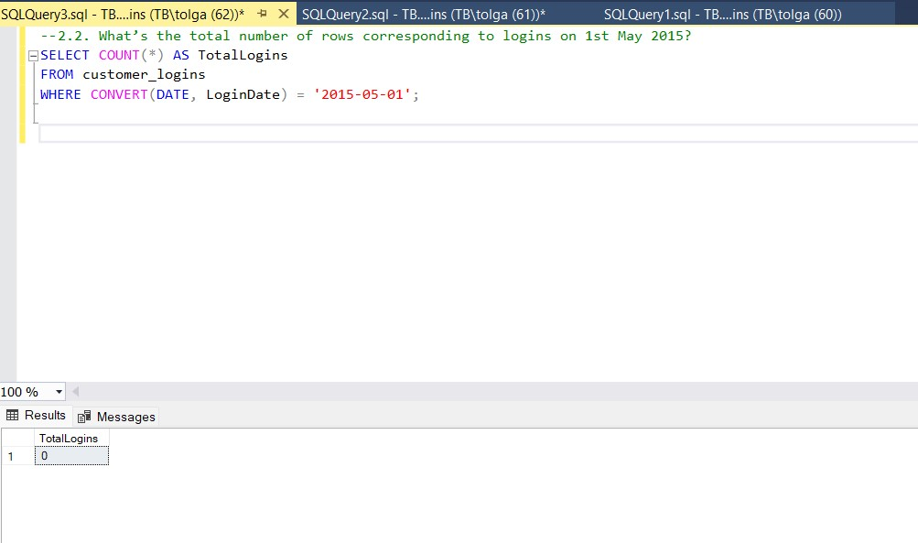
2.3
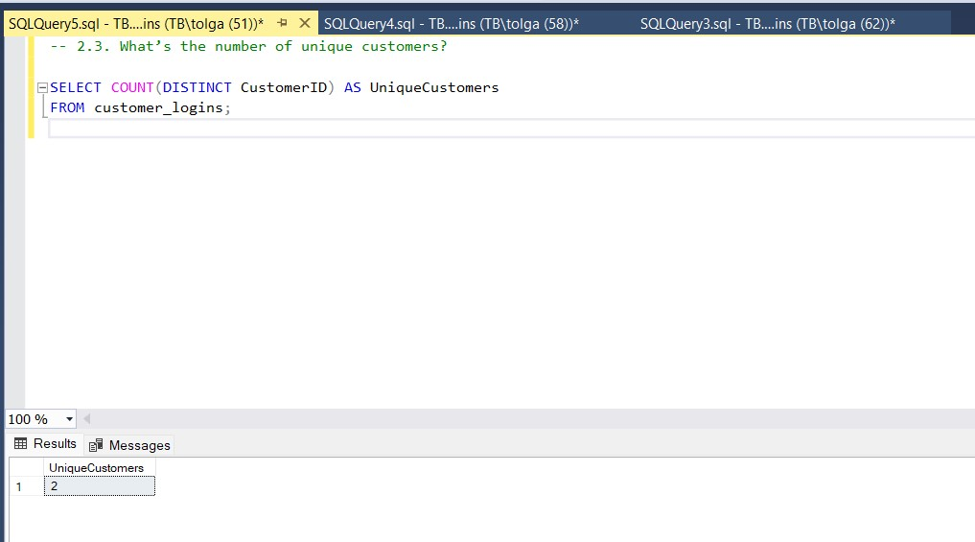

2.4
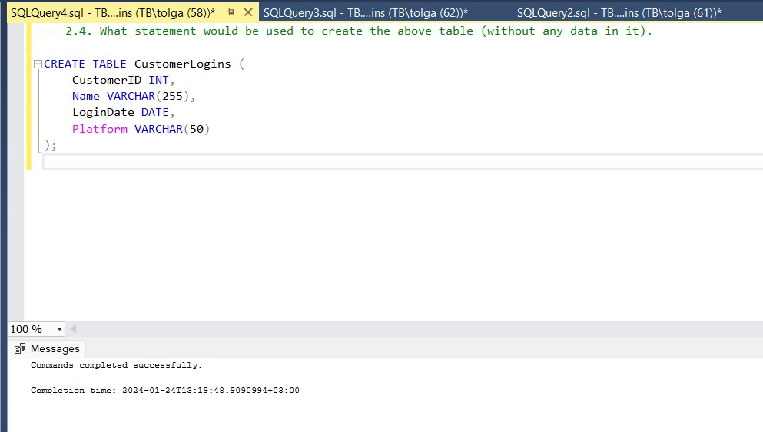
2.5. In SQL, what is the difference between an inner join and an outer join? Please give an example of some circumstances where you would recommend using an outer join?
Inner Join:
- An inner join returns only the rows where there is a match in both tables based on the specified join condition.
- It filters out rows from both tables that do not meet the specified condition.
Example:
SELECT employees.employee_id, employees.employee_name, departments.department_name
FROM employees
INNER JOIN departments ON employees.department_id = departments.department_id;

In this example, only the rows with matching department_id values in both the employees and departments tables will be included in the result set.

Outer Join:
An outer join returns all the rows from one table and the matching rows from another table. If there is no match, the result will still include rows from the table without a match, with NULL values in the columns from the other table.
There are three types of outer joins:
Left Outer Join (or Left Join): Returns all rows from the left table and the matching rows from the right table. If there's no match in the right table, NULL values are returned for columns from the right table.
Example:
SELECT employees.employee_id, employees.employee_name, departments.department_name
FROM employees
LEFT JOIN departments ON employees.department_id = departments.department_id;
Right Outer Join (or Right Join): Returns all rows from the right table and the matching rows from the left table. If there's no match in the left table, NULL values are returned for columns from the left table.
Example:
SELECT employees.employee_id, employees.employee_name, departments.department_name
FROM employees
RIGHT JOIN departments ON employees.department_id = departments.department_id;

Full Outer Join: Returns all rows when there is a match in either the left or right table. If there's no match, NULL values are returned for columns from the table without a match.
SELECT employees.employee_id, employees.employee_name, departments.department_name
FROM employees
FULL OUTER JOIN departments ON employees.department_id = departments.department_id;

Circumstances for Using Outer Join:
- Use an outer join when you want to retrieve all records from one table and include matching records from another table.
- Outer joins are particularly useful when you want to include records that might not have corresponding matches in the other table.
Example scenario:
Suppose you have a table of employees and a table of projects. You want to retrieve a list of all employees and the projects they are working on, even if some employees are not currently assigned to any project. In this case, a left outer join from the employees table to the projects table would be appropriate. This ensures that all employees are included in the result, and those without projects will have NULL values in the project-related columns.

Question 3
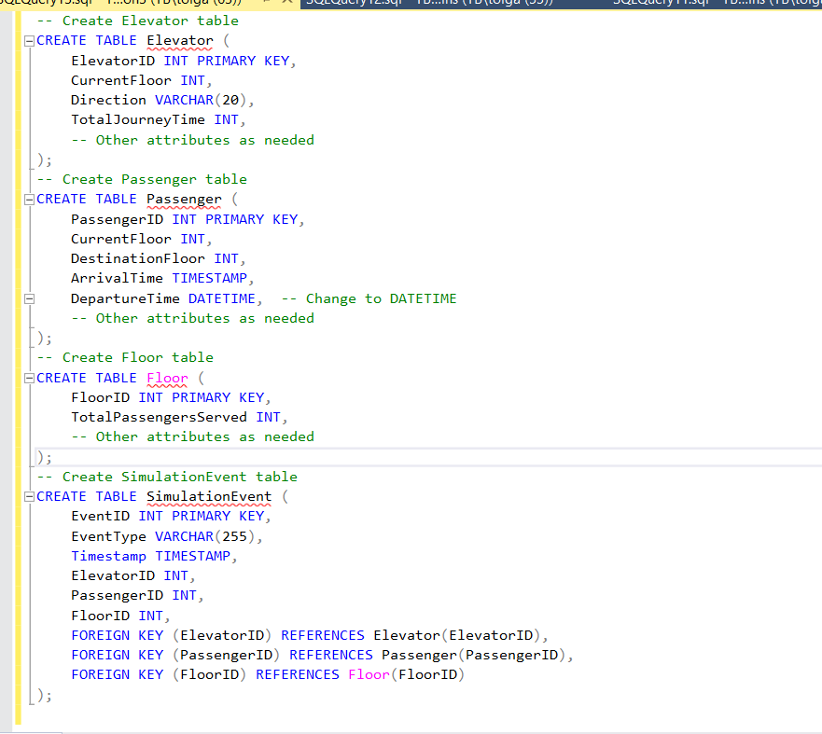
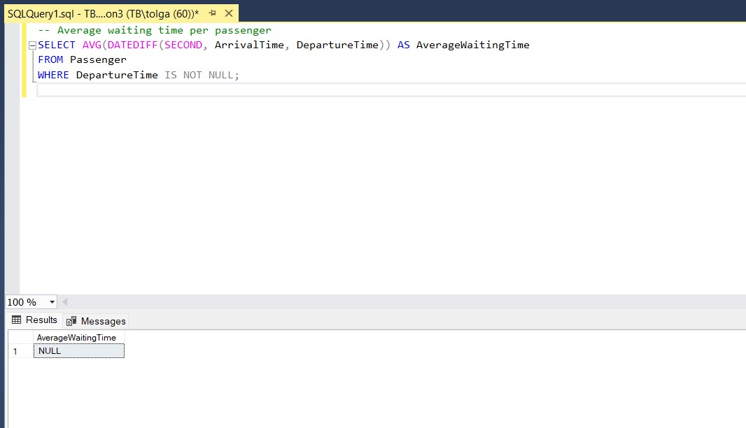
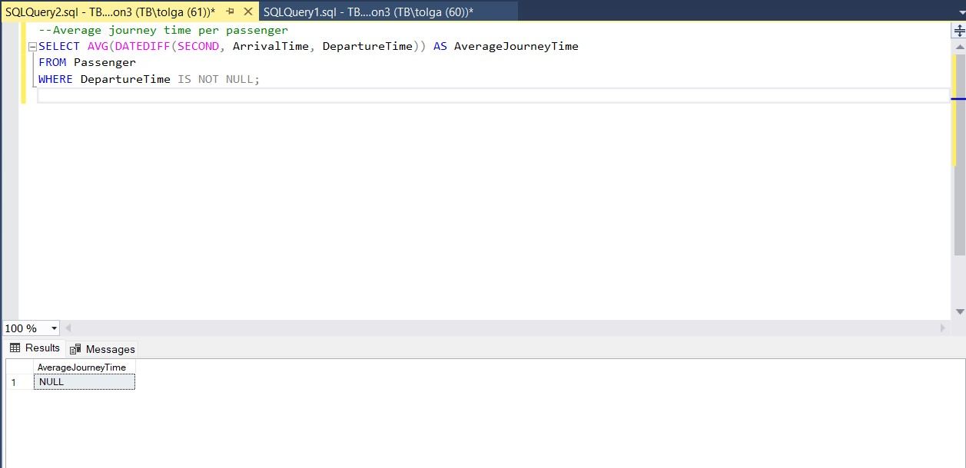

3.1
-- Create Stakeholder table
CREATE TABLE Stakeholder (
StakeholderID INT PRIMARY KEY,
StakeholderType VARCHAR(50),
StakeholderName VARCHAR(255),
ContactInformation VARCHAR(255)
-- Add other attributes as needed
);

-- Create ElevatorStakeholderRelationship table
CREATE TABLE ElevatorStakeholderRelationship (
RelationshipID INT PRIMARY KEY,
ElevatorID INT,
StakeholderID INT,
RelationshipType VARCHAR(50),
FOREIGN KEY (ElevatorID) REFERENCES Elevator(ElevatorID),
FOREIGN KEY (StakeholderID) REFERENCES Stakeholder(StakeholderID)
);

-- Insert data into Stakeholder table
INSERT INTO Stakeholder (StakeholderID, StakeholderType, StakeholderName, ContactInformation)
VALUES
(1, 'Building Owner', 'ABC Real Estate', 'owner@abc.com'),
(2, 'Tenant', 'XYZ Corporation', 'tenant@xyz.com');

-- Insert data into Elevator table
INSERT INTO Elevator (ElevatorID, CurrentFloor, Direction, TotalJourneyTime)
VALUES
(1, 0, 'stationary', 0),
(2, 0, 'stationary', 0);

-- Insert data into ElevatorStakeholderRelationship table
INSERT INTO ElevatorStakeholderRelationship (RelationshipID, ElevatorID, StakeholderID, RelationshipType)
VALUES
(1, 1, 1, 'Owner'), -- Ensure that ElevatorID 1 exists in the Elevator table.
(2, 2, 2, 'Tenant'); -- Ensure that ElevatorID 2 exists in the Elevator table.
-- Add other relationships as needed.

3.2
- I don’t understand this question but I guess;
1. **Response Time Metrics:**
- **Average response time to elevator calls:**
```sql
SELECT AVG(ResponseTime) AS AverageResponseTime
FROM ElevatorCalls;
```

- **Maximum response time during peak hours:**
```sql
SELECT MAX(ResponseTime) AS MaxResponseTime
FROM ElevatorCalls
WHERE HOUR(CallTimestamp) BETWEEN 8 AND 17; -- Assuming peak hours between 8 AM and 5 PM
```

2. **Capacity Utilization Metrics:**
- **Average and peak elevator occupancy rates:**
```sql
SELECT
AVG(OccupancyRate) AS AverageOccupancyRate,
MAX(OccupancyRate) AS PeakOccupancyRate
FROM ElevatorUsage;
```

3. **Maintenance Effectiveness Metrics:**
- **Mean Time To Repair (MTTR) for elevator breakdowns:**
```sql
SELECT AVG(DATEDIFF(MINUTE, BreakdownStart, BreakdownResolved)) AS AvgMTTR
FROM ElevatorBreakdowns
WHERE BreakdownResolved IS NOT NULL;
```

- **Percentage of preventive maintenance tasks completed on schedule:**
```sql
SELECT
(COUNT(CASE WHEN MaintenanceType = 'Preventive' AND CompletedOnSchedule = 1 THEN 1 END) /
COUNT(CASE WHEN MaintenanceType = 'Preventive' THEN 1 END)) * 100
AS PreventiveMaintenanceCompletionRate
FROM MaintenanceTasks;
```

4. **Energy Consumption Metrics:**
- **Average energy consumption per trip:**
```sql
SELECT AVG(EnergyConsumption) AS AverageEnergyConsumption
FROM ElevatorEnergyUsage;
```

- **Energy efficiency rating of elevator systems:**
*(Assuming a simple efficiency rating system)*
```sql
SELECT
CASE
WHEN AVG(EnergyConsumption) < 5 THEN 'Highly Efficient'
WHEN AVG(EnergyConsumption) BETWEEN 5 AND 10 THEN 'Moderately Efficient'
ELSE 'Less Efficient'
END AS EnergyEfficiencyRating
FROM ElevatorEnergyUsage;
```

3.3 diagram
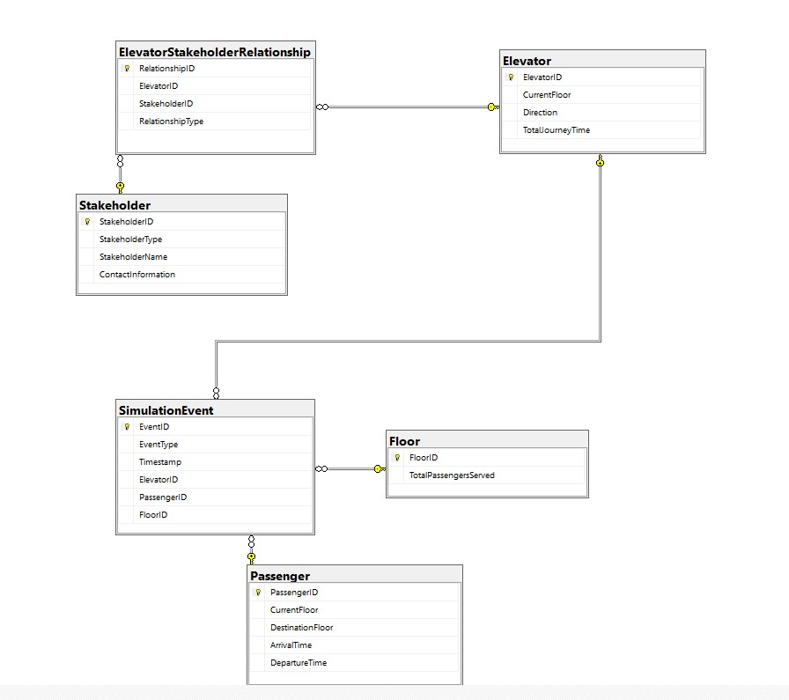

3.4
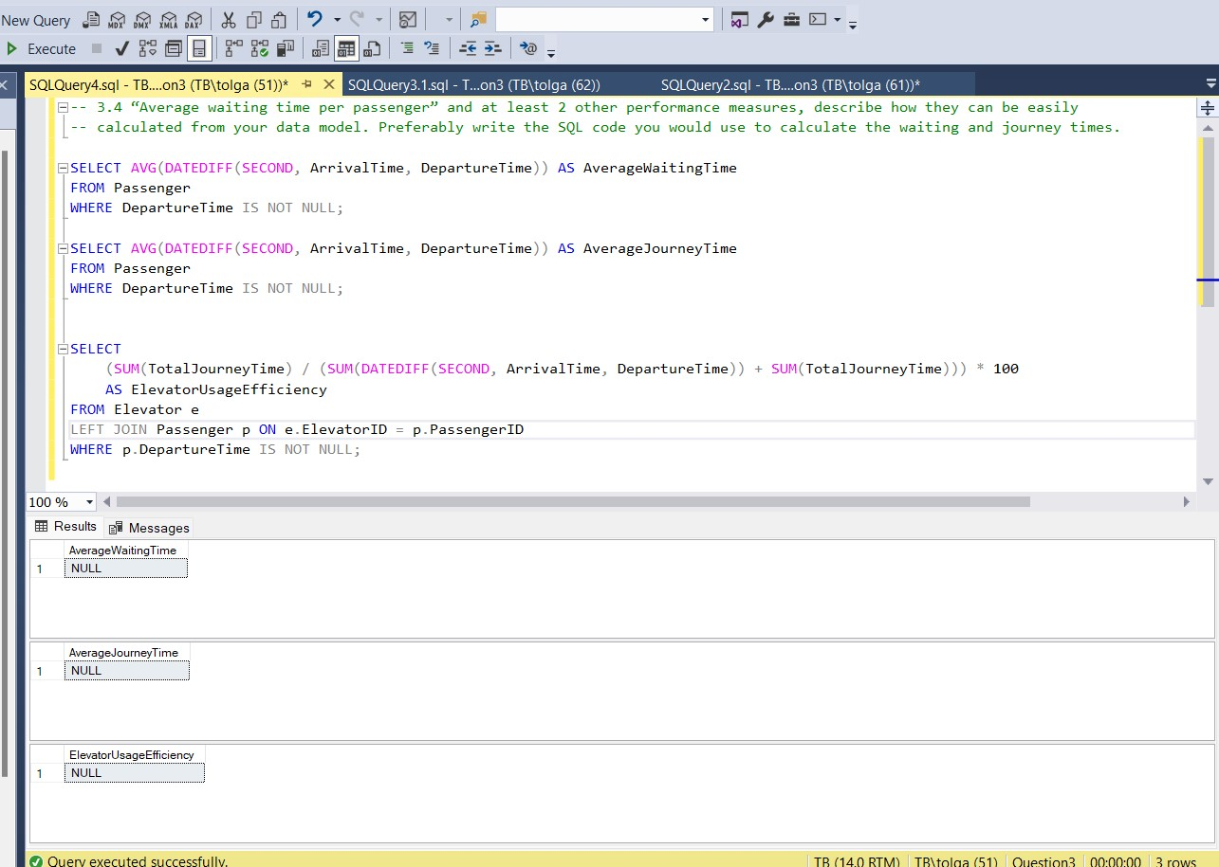

Question 4
Graph like “parkinson’s law”
4.1 What standard measures are a, b and c most likely denoting? Please explain why.
Mode: a, point a is most likely the mode as it represents the most frequent value in the dataset.
Median: b, which is the middle value when the data is ordered from least to greatest.
Mean: c, point c correctly denotes the mean, which is the average of all the data points.

4.2. If you drew n samples from this distribution and measured their mean, then repeated that many times, how would you expect the distribution of those sample means to differ from this distribution?
When you draw multiple samples from a population and calculate the mean of each sample, you are dealing with the sampling distribution of the mean. According to the Central Limit Theorem (CLT), as long as the sample size is sufficiently large, the distribution of sample means will be approximately normally distributed, regardless of the shape of the original population distribution.

4.3 Would its standard deviation be bigger, smaller, or the same as this distribution's standard deviation and why?
The standard deviation of the sampling distribution of the mean is smaller than the standard deviation of the original population distribution. This phenomenon is a consequence of the Central Limit Theorem (CLT)
As you can see, the standard deviation of the sample mean is inversely proportional to the square root of the sample size. This means that as you increase the sample size, the standard deviation of the sample mean decreases.
So, when you draw multiple samples and calculate their means, the spread of those sample means will be smaller than the spread of the original population. This is one of the reasons why the Central Limit Theorem is valuable in statistical inference, as it allows us to make more precise statements about the mean based on sample means, especially when the sample size is large.

Question 5
The following two pages contain our “Data Science competency matrix”. Please rate yourself on a scale from 1-5 in each of the areas in the matrix:

1- Coding: 4
2- SQL: 4
3- Stats: 3

Question 6
What does your favorite workplace look like?
My favorite workplace is where colleagues work towards the company's goal, find solutions to problems together and motivate each other. Being an environment where knowledge and experiences in technical skills are transferred to each other will move both employees and the company forward. Additionally, without wasting time by working in a remote working environment. An environment where they can focus on their work and not waste time in traffic would be better.

